ASSIGNMENTS

1. **LINKEDIN PROFILE**

URL: <https://www.linkedin.com/in/manimegalai-p-750b32270>

1. **BRAND LOGO AND BRAND NAME PROMOTION ON FACEBOOK**

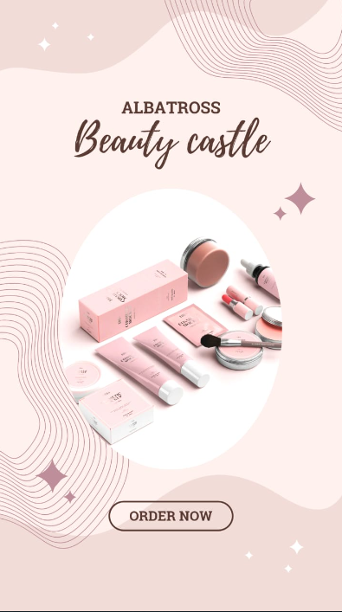

BRAND LOGO

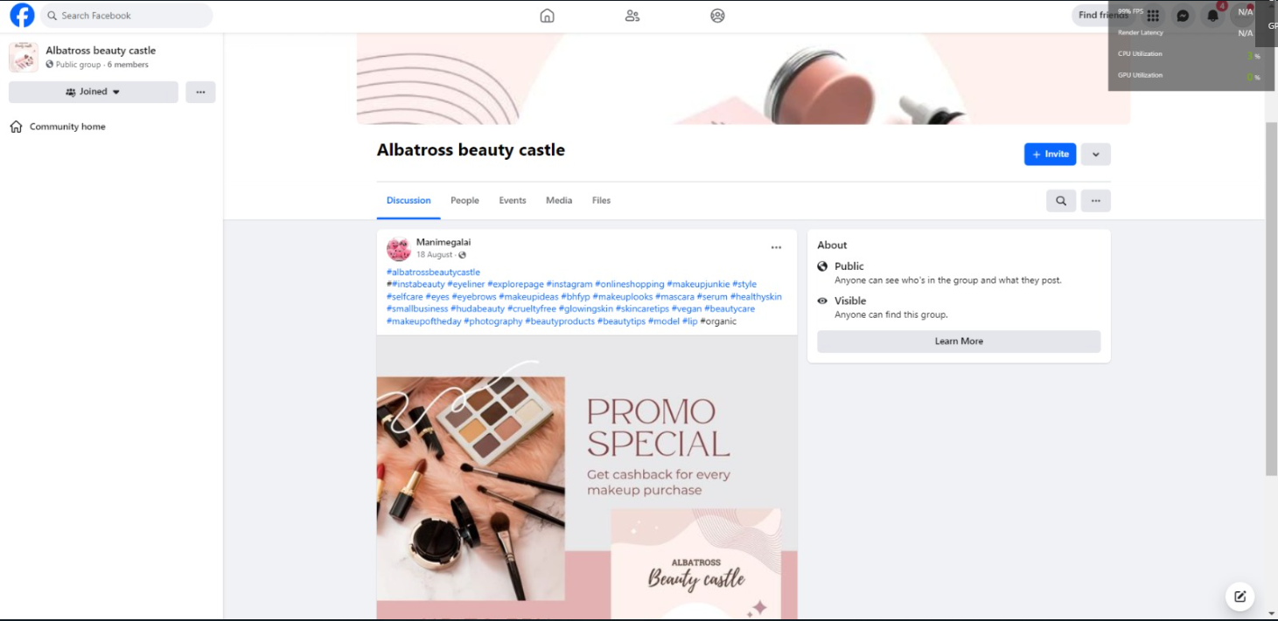

BRAND NAME PROMOTION ON FACEBOOK

1. **BLOGGER WEBSITE**

URL: <https://www.blogger.com/blog/posts/3986330889152816599>

/

1. **EMAIL NEWSLETTER**

URL:<https://miniathi.blogspot.com/2023/10/email-newsletter-happy-children.html>

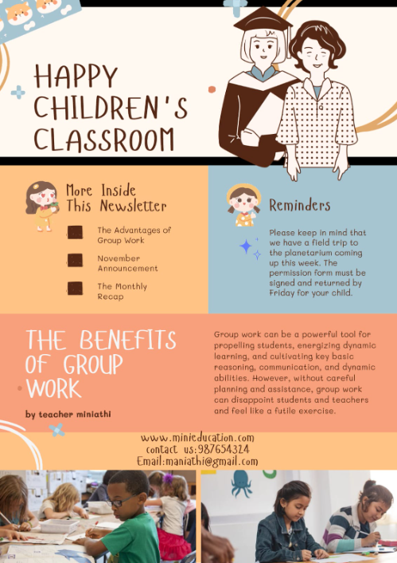

1. **INFOGRAPHICS**

URL : <https://miniathi.blogspot.com/2023/10/infography-milestone-in-space.html>

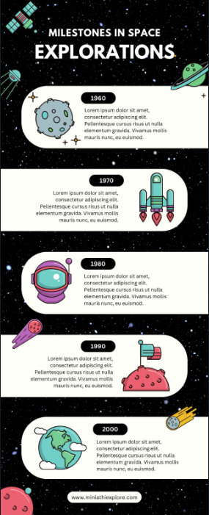

1. ARTICLE

URL:<https://miniathi.blogspot.com/2023/10/articles-exploring-desert.html>

